# Ideation Phase

Define the problem statements

|  |  |
| --- | --- |
| Team ID | 88A47BC9080CDE499E844AF1A08CEE03 |
| Project name | Creating an Sponsored Post for Instagram |

Create a problem statement to understand your customer's point of view. The Customer Problem Statement template helps you focus on what matters to create experiences people will love.

A well-articulated customer problem statement allows you and your team to find the ideal solution for the challenges your customers face. Throughout the process, you’ll also be able to empathize with your customers, which helps you better understand how they perceive your product or service.

# Definition of problem diagram

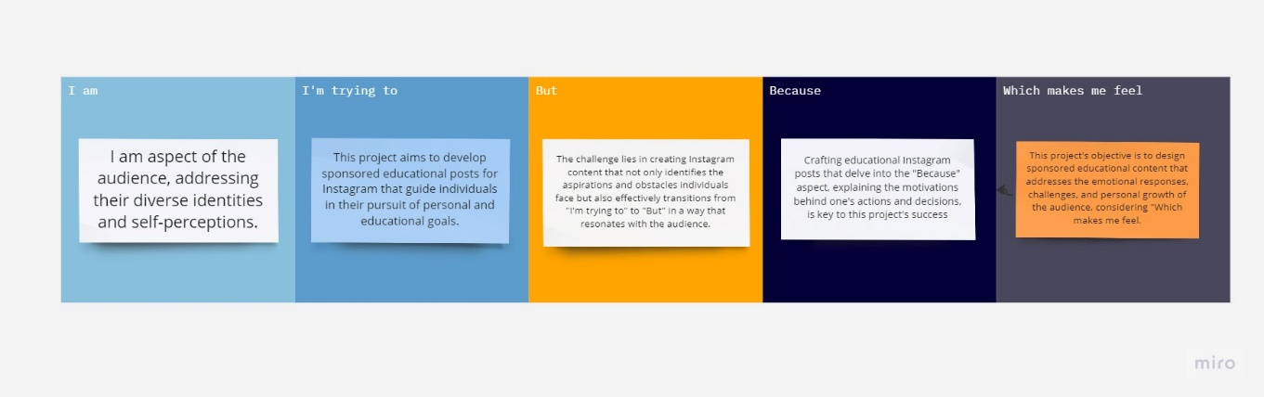

Reference link :<https://miro.com/app/board/uXjVNTAx1GQ=/?share_link_id=538835161111>

|  |  |  |  |  |  |
| --- | --- | --- | --- | --- | --- |
| Problem statement | I am | I’m trying  to | But | Because | Which  make me feel |
| PS | he challenge is to create sponsored educational Instagram content that effectively explores the "I am" aspect of the audience, addressing their diverse identities and self-perceptions | This project aims to develop sponsored educational posts for Instagram that guide individuals in their pursuit of personal and educational goals, answering the question of "I'm trying to." | The challenge lies in creating Instagram content that not only identifies the aspirations and obstacles individuals face but also effectively transitions from "I'm trying to" to "But" in a way that resonates with the audience | Crafting educational Instagram posts that delve into the "Because" aspect, explaining the motivations behind one's actions and decisions, is key to this project's success. | This project's objective is to design sponsored educational content that addresses the emotional responses, challenges, and personal growth of the audience, considering "Which makes me feel." |